**Threads Synchronization**

**LAB # 8**



Spring 2022

CSE204L Operating Systems Lab

**Submitted by:Maaz Habib, Alishba Orakzai, Nida Asmat Burki**

**Registration No.: 20PWCSE1952,20pwcse1953, 20pwcse1955**

**Section:**

C

**“On my honor, as student of University of Engineering and Technology, I have neither given nor received unauthorized assistance on this academic work.”**

Student Signature:

**Submitted to:**

Engr. Mian Ibad Ali Shah

June 9, 2022

**Department of Computer Systems Engineering University of Engineering and Technology, Peshawar**

**Lab Objective(s):**

* Solve the Critical Section Problem
* Implement different Process Scheduling Algorithms.

**Task # 01:**

Solve the critical section problem using:

* Peterson solution
* Test and set instruction
* producer/consumer problem

**Peterson Solution:**

**Code:**

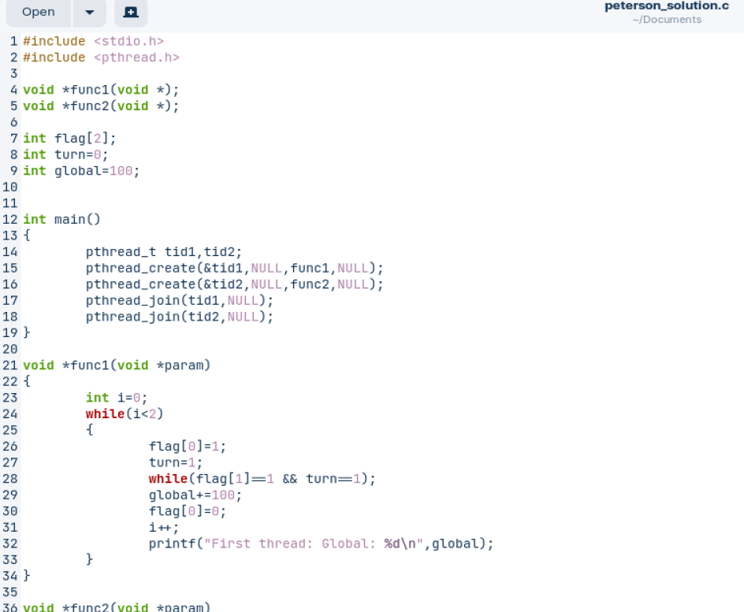

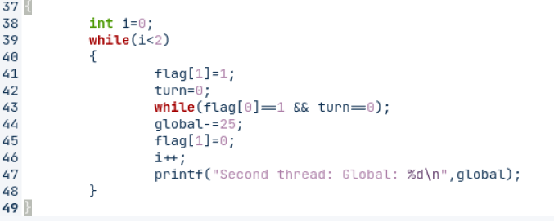

**Output:**

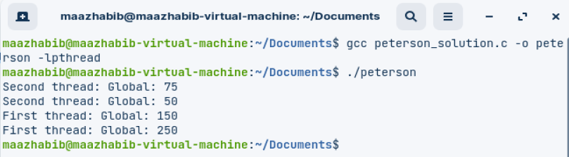

**Test and set instruction:**

**Code:**

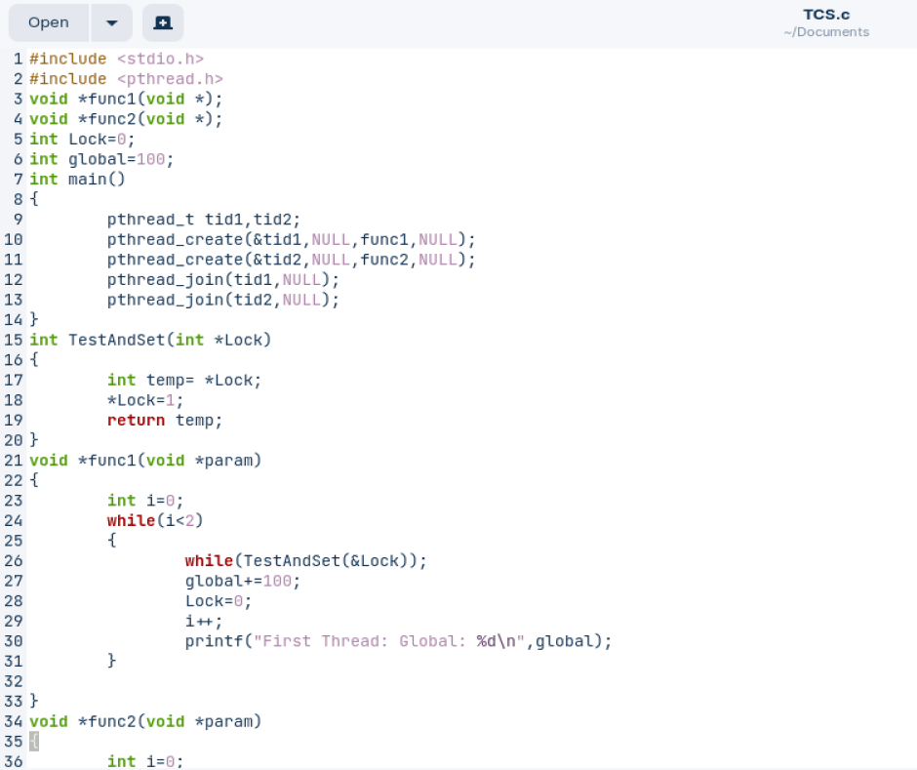

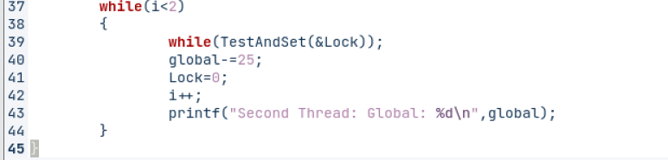

**Output:**

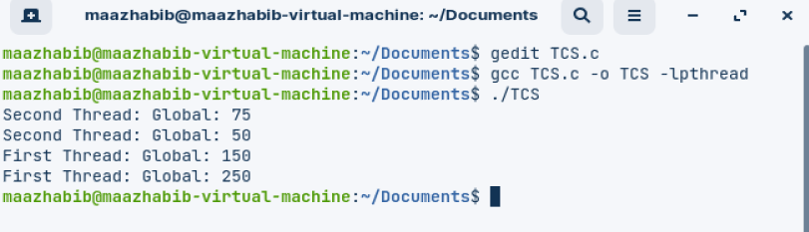

**Producer/Consumer Problem:**

**Code:**

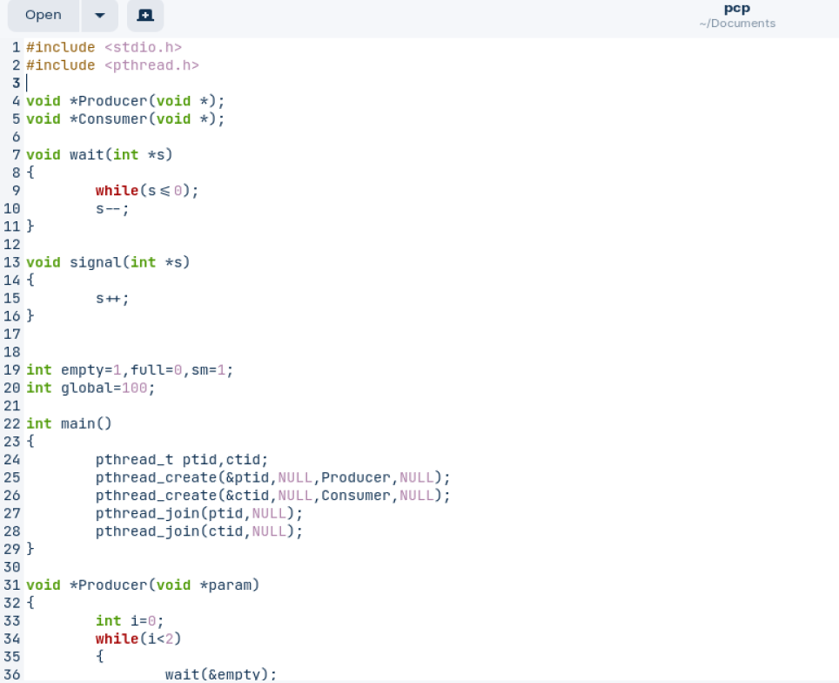

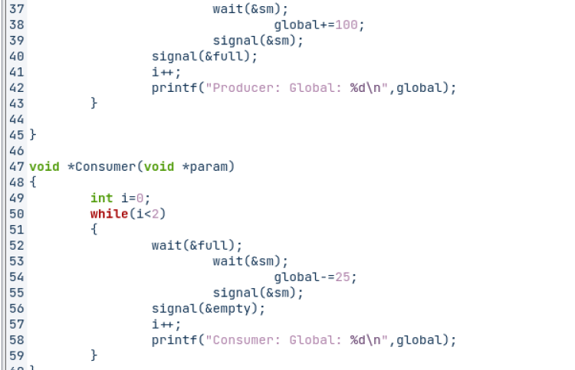

**Output:**

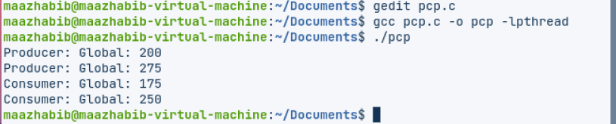

**Task # 02:**

Simulate the following Process Scheduling Algorithms:

* First Come First Serve
* Shortest Job First
* Priority Scheduling
* Shortest Time Remaining First

**First Come First Serve:**

**Code:**

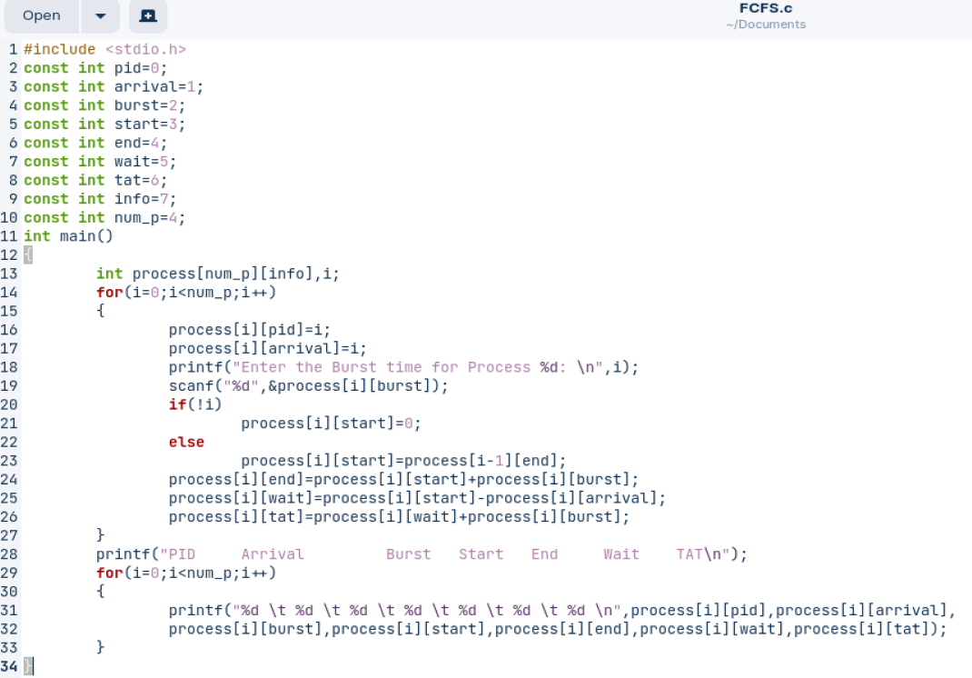

**Output:**

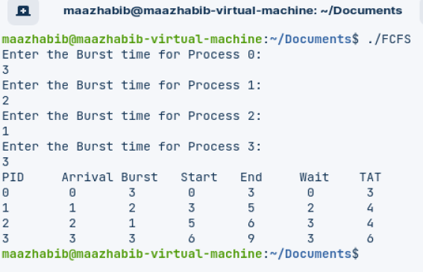

**Shortest Job First:**

**Code:**

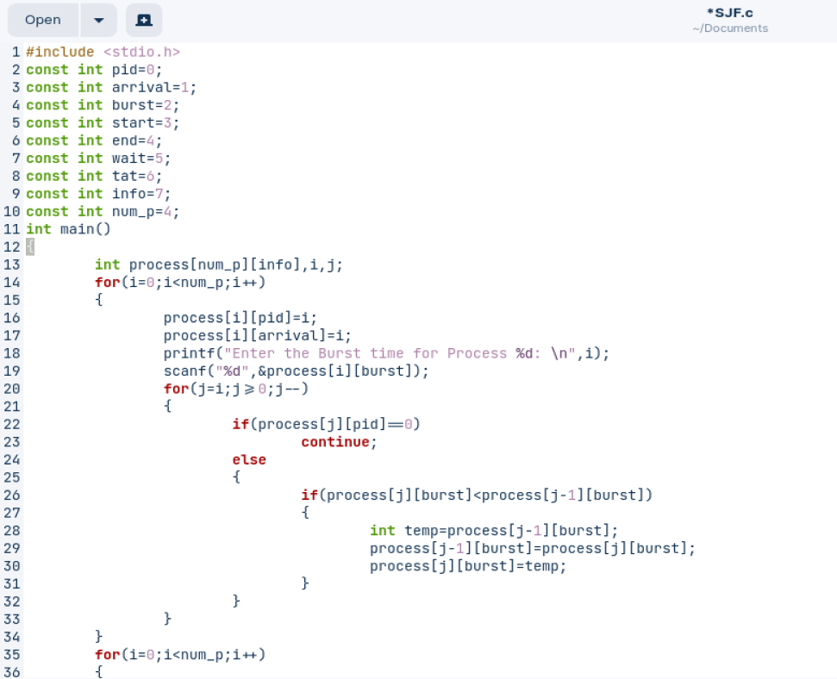

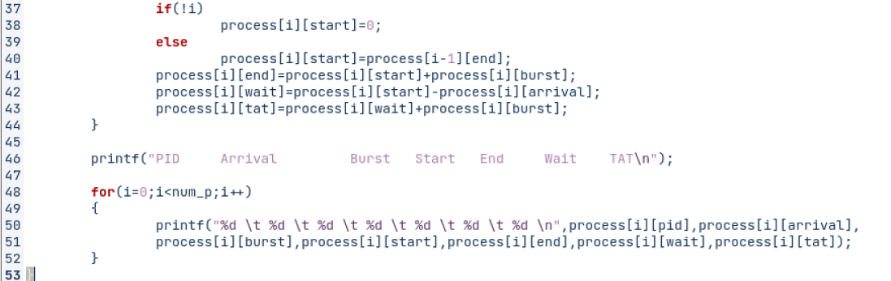

**Output:**

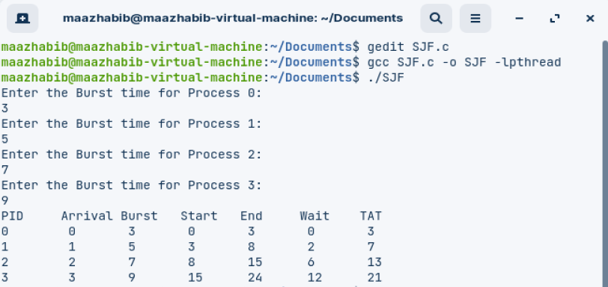

**Priority Scheduling:**

**Code:**

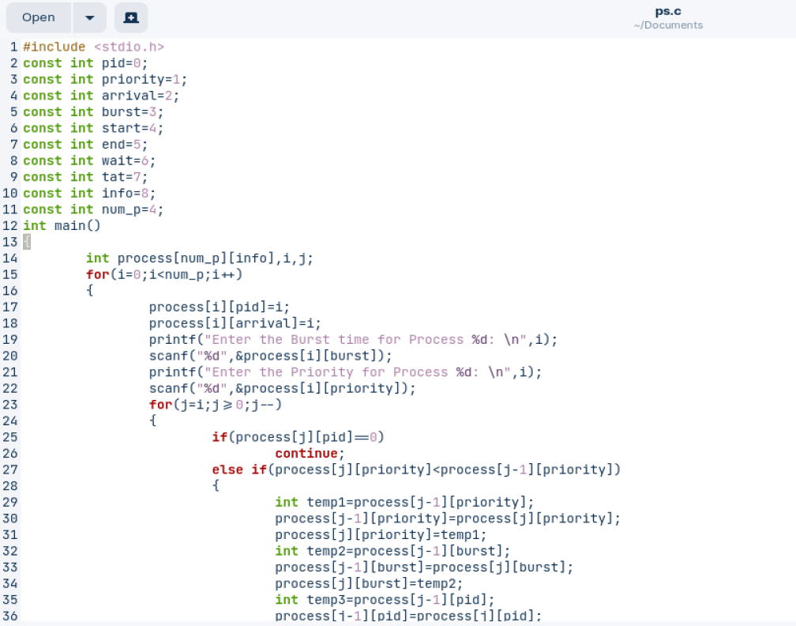

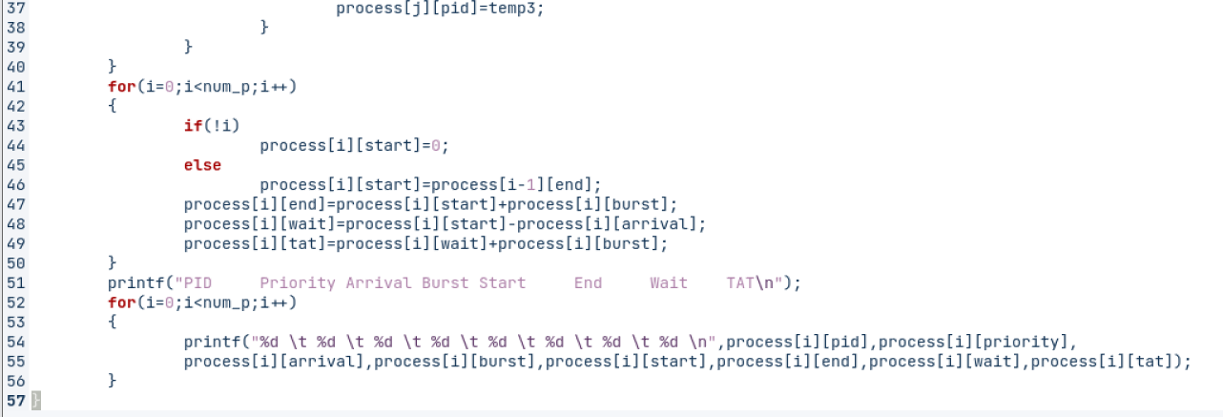

**Output:**

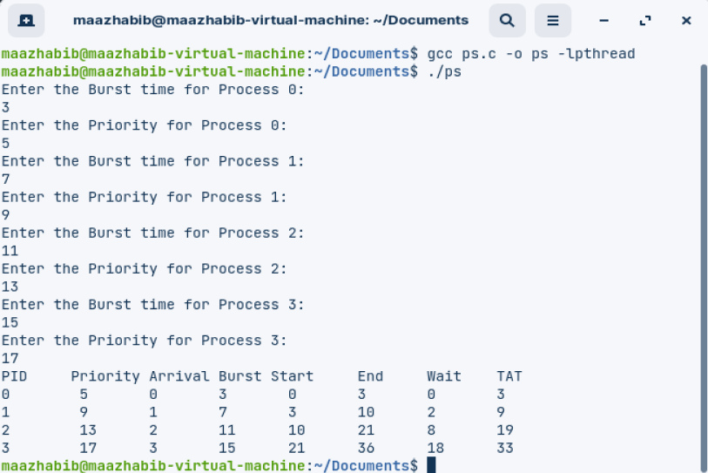

**Shortest Time Remaining First:**

**Code:**

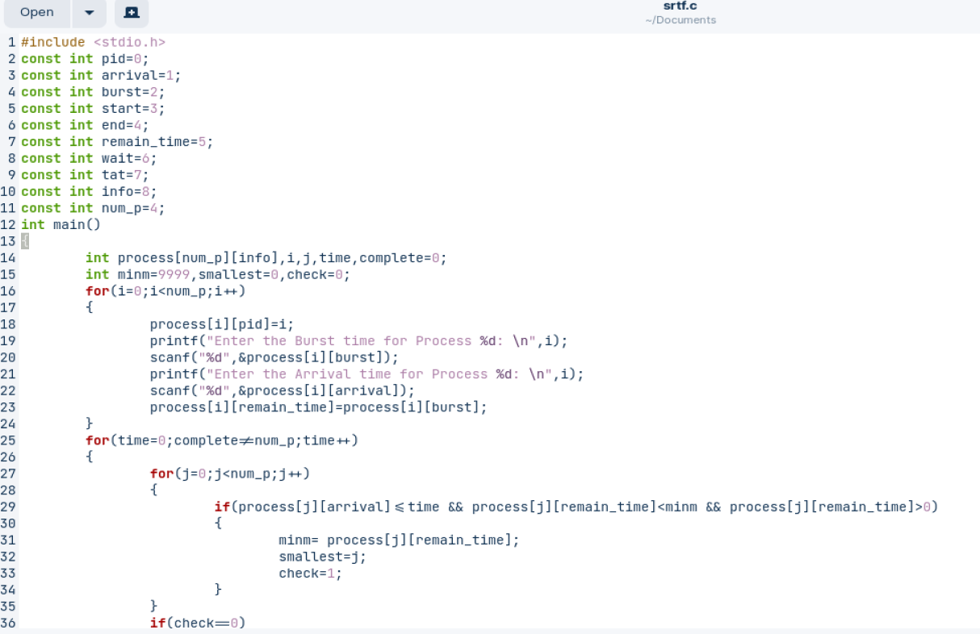

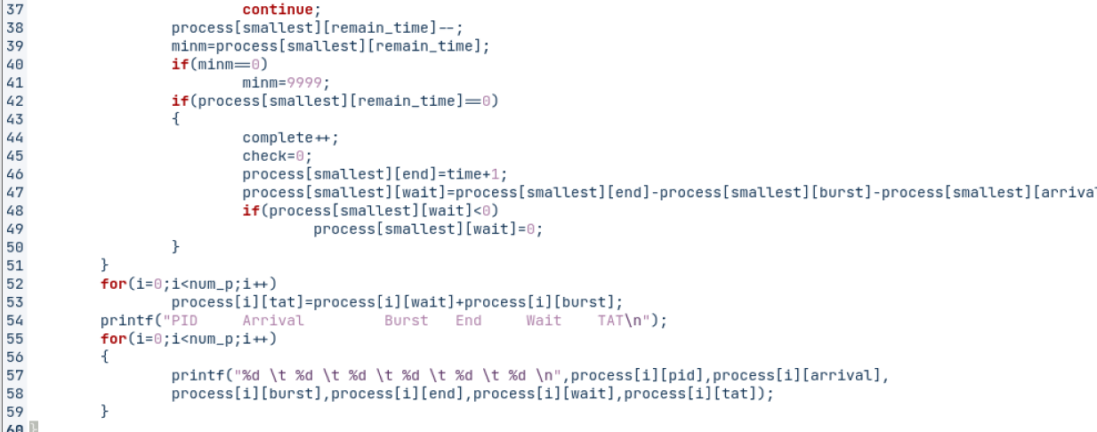

**Output:**

